CHAPTER 6: INTRODUCTION TO FUNCTIONS
TOPICS COVERED:
6.1 WHAT IS FUNCTION
6.2 WHY FUNCTION?
6.3 HOW TO DEFINE A FUNCTION
6.4 TYPES OF FUNCTION
6.4.1 BUILT IN FUNCTIONS
6.4.2 MATH FUNCTIONS
6.4.3 USER DEFINED FUNCTION
6.4.4 TYPES OF ARGUMENTS USED IN USER DEFINED FUNCTION
6.4.5 RECURSIVE FUNCTION
6.4.6 LAMBDA FUNCTION

6.1 WHAT IS FUNCTION
- Function in python is a structured code template that is used to perform a specific action when it gets called.
- Function is also used to take input values at run time and process it with function body by perform its specific action to produce and returns processed output values.

6.2 WHY FUNCTION?
Python functions are frequently used to achieve the following
- Code reusability
- Define name space
- Reduce complexity
- Returns processed output values
- Optimize memory
6.3 HOW TO DEFINE A FUNCTION
Use the following principles to define a function in python.
- Use def at the beginning.
- Give a meaningful function name that never starts with number.
- Assign parameters to function inside parenthesis ().
- Invoke indentation space by putting (:) after function parameters.
- Function body with optional arguments.
- Display processed output values using return statement.
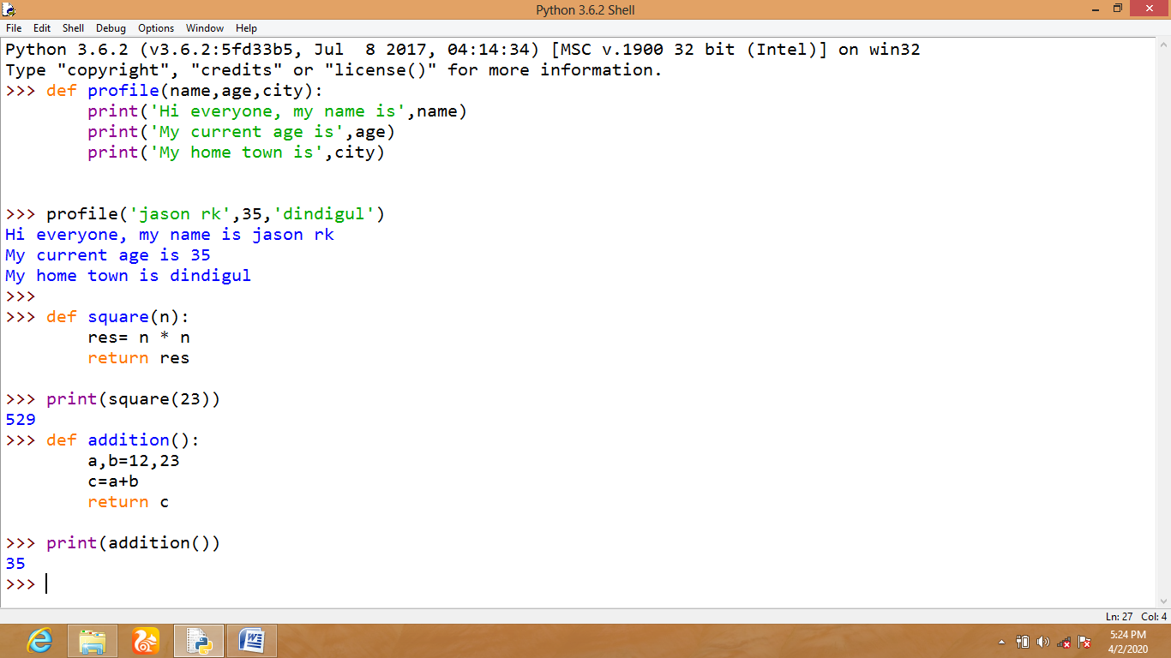
6.4 TYPES OF FUNCTION
6.4.1 BUILT IN FUNCTIONS
- Built in functions in python are bundled with standard library.
- Built in functions are also known as implicit functions.
- Built in functions are represented in purple color
Some important built in functions are,
[NOTE: import builtins module in python idle so that it will display all the built in functions and built in exceptions and errors]
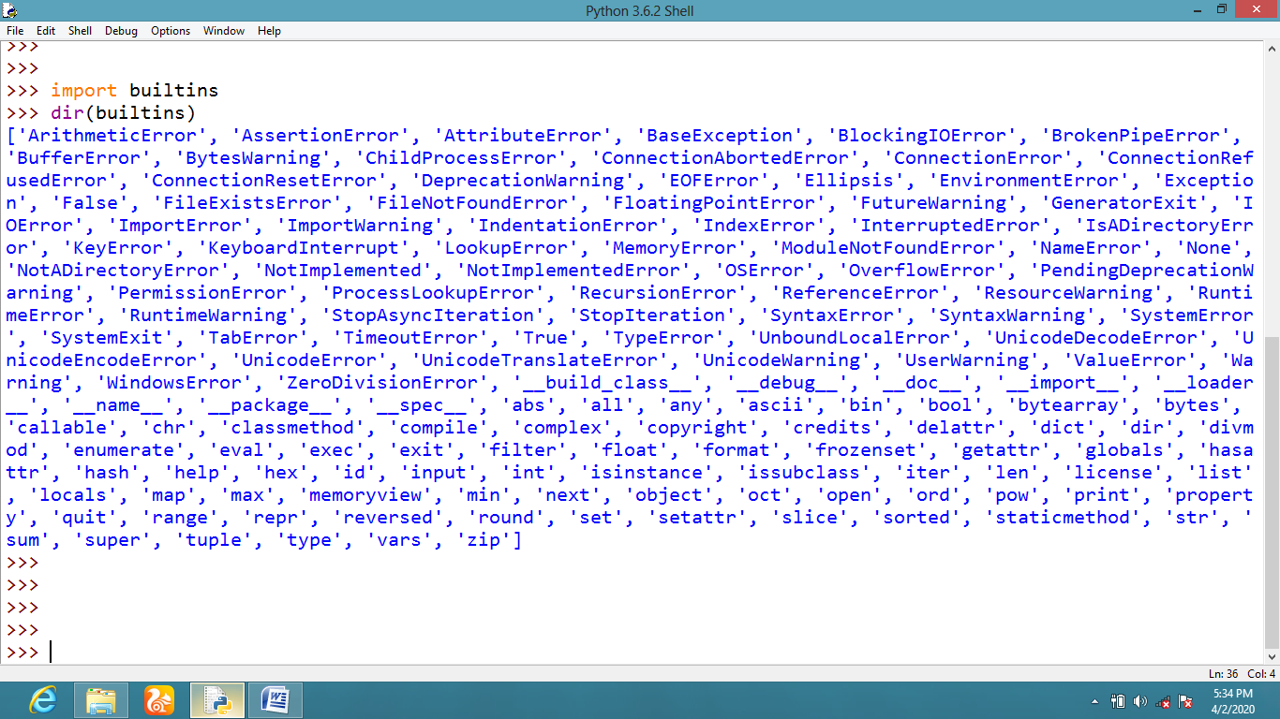
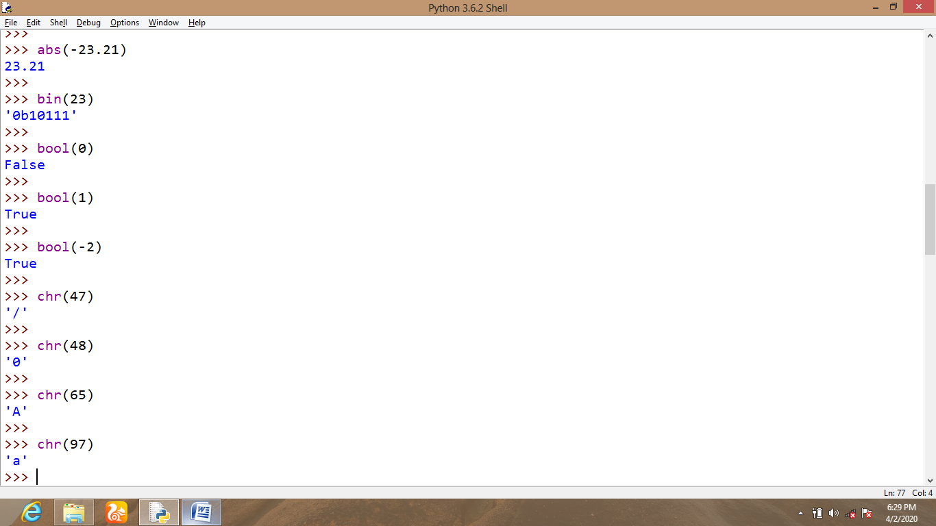

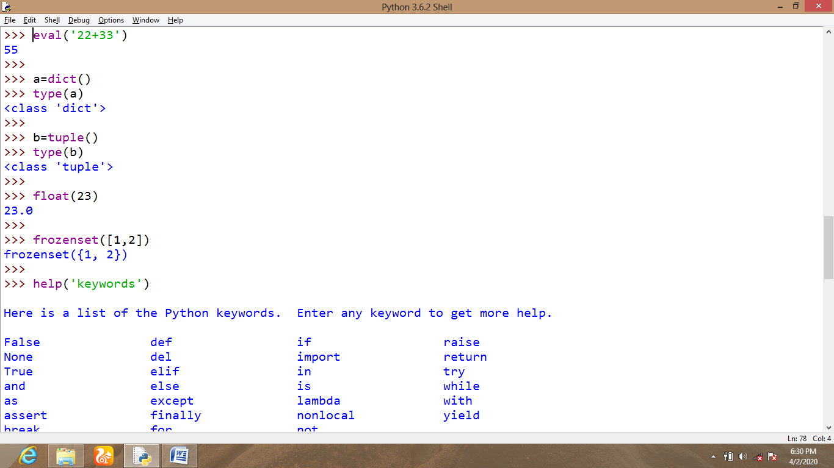

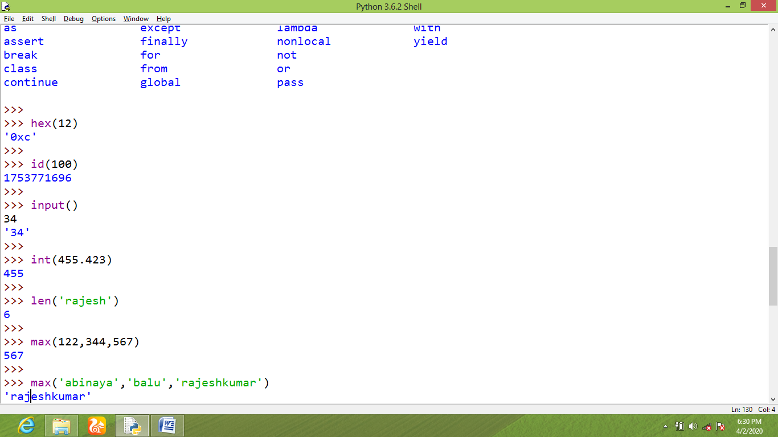
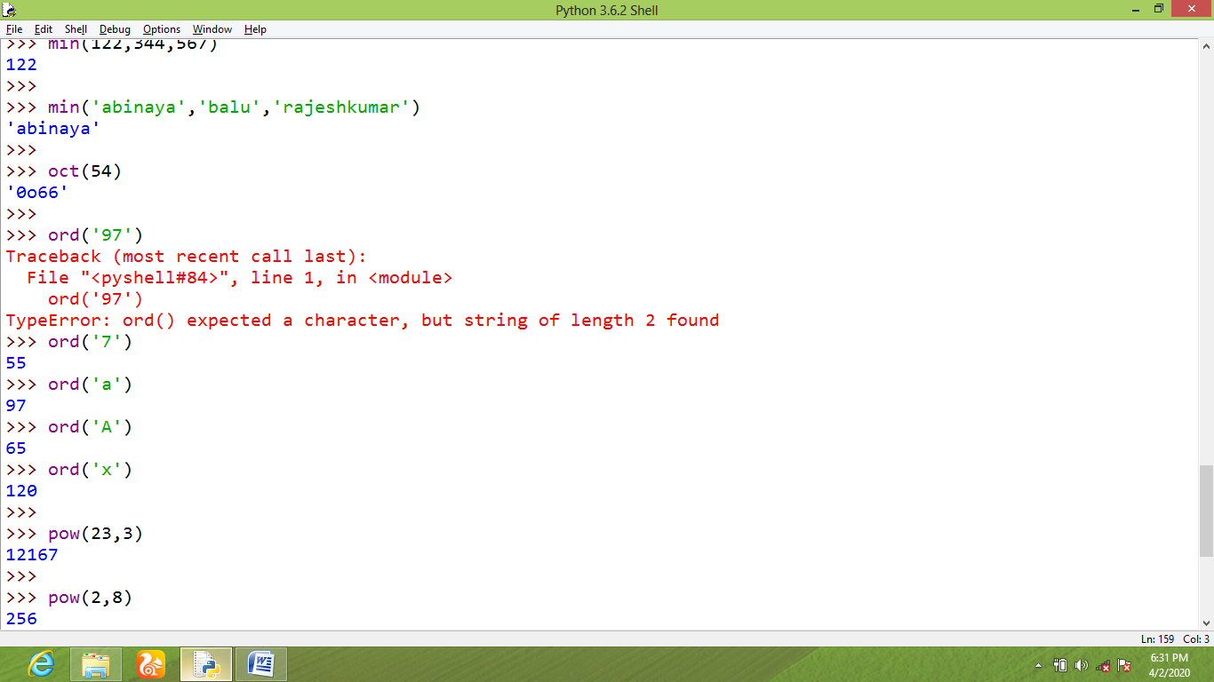
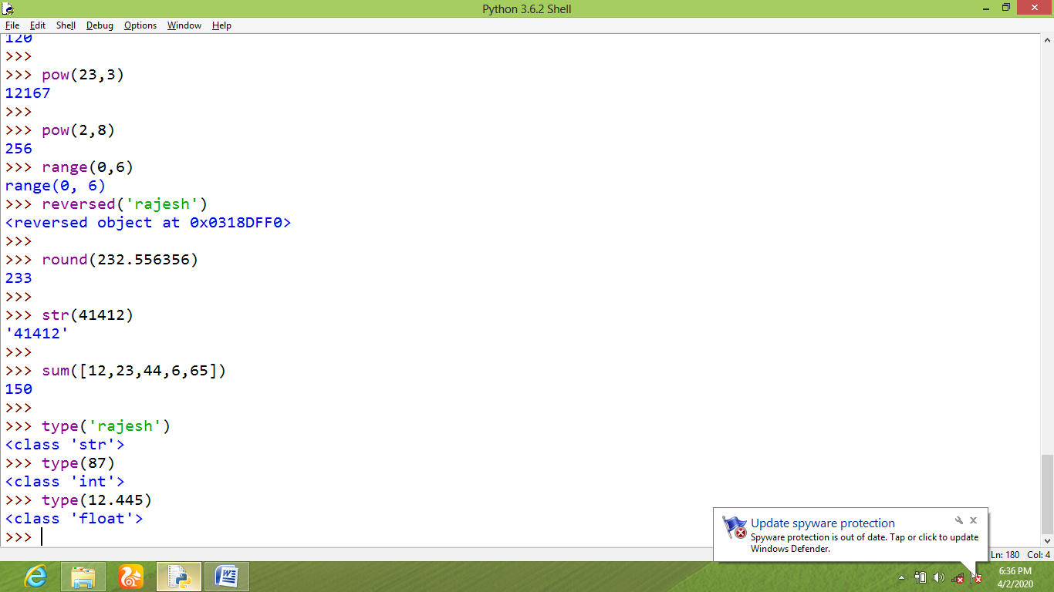
6.4.2. MATH FUNCTIONS
Use math module to invoke all the mathematical related functions in python scripts.
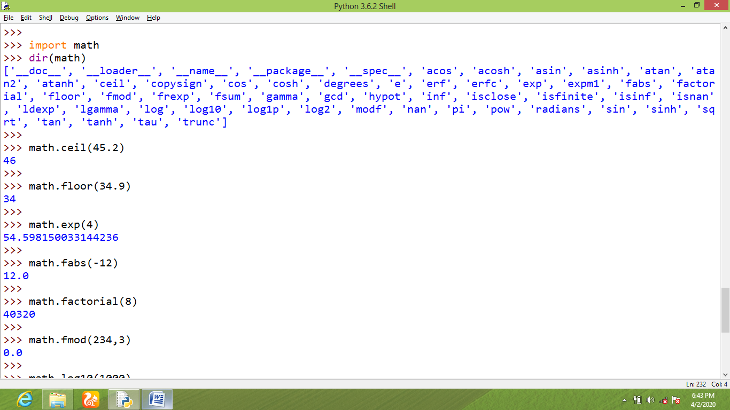
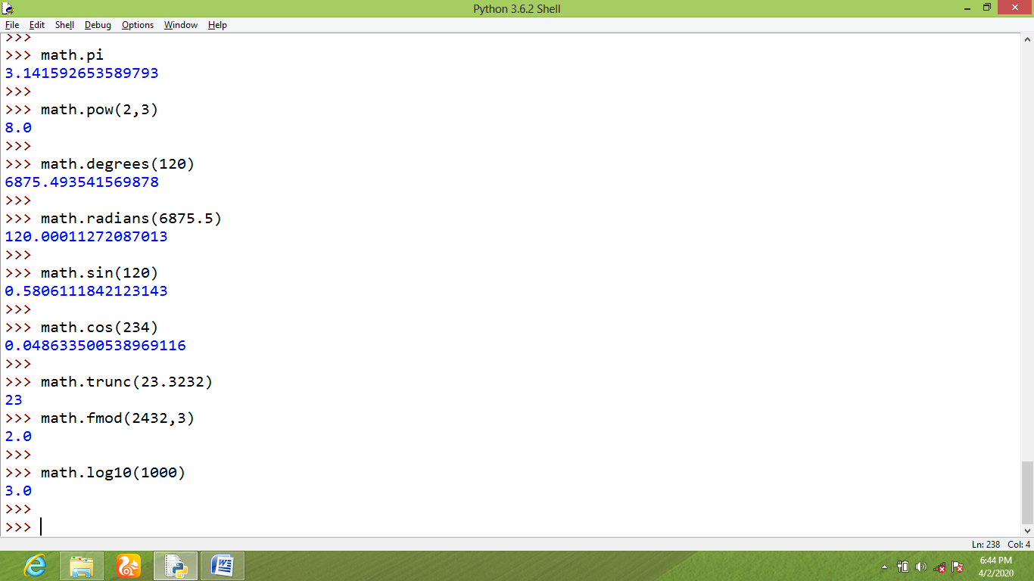
6.4.3. USER DEFINED FUNCTIONS
- User defined functions are created by the user to perform a specific action which returns or prints processed output values explicitly.
- Follow the rules of defining functions to create customized functions that can be used as module when it is needed.
[NOTE: In python functions, parameters are acting like data holders and arguments are acting like actual values which can be bonded over declared parameters]
6.4.4 ARGUMENTS USED IN USER DEFINED FUNCTIONS
1. Default arguments
2. Keyword arguments
3. Positional arguments
4. Arbitrary arguments
Some sample programs will explain everything about arguments in detail.
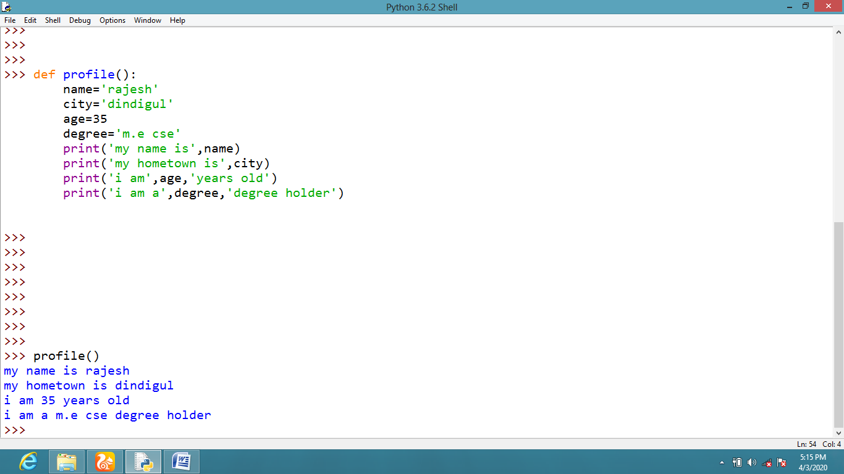
User defined functions with default arguments
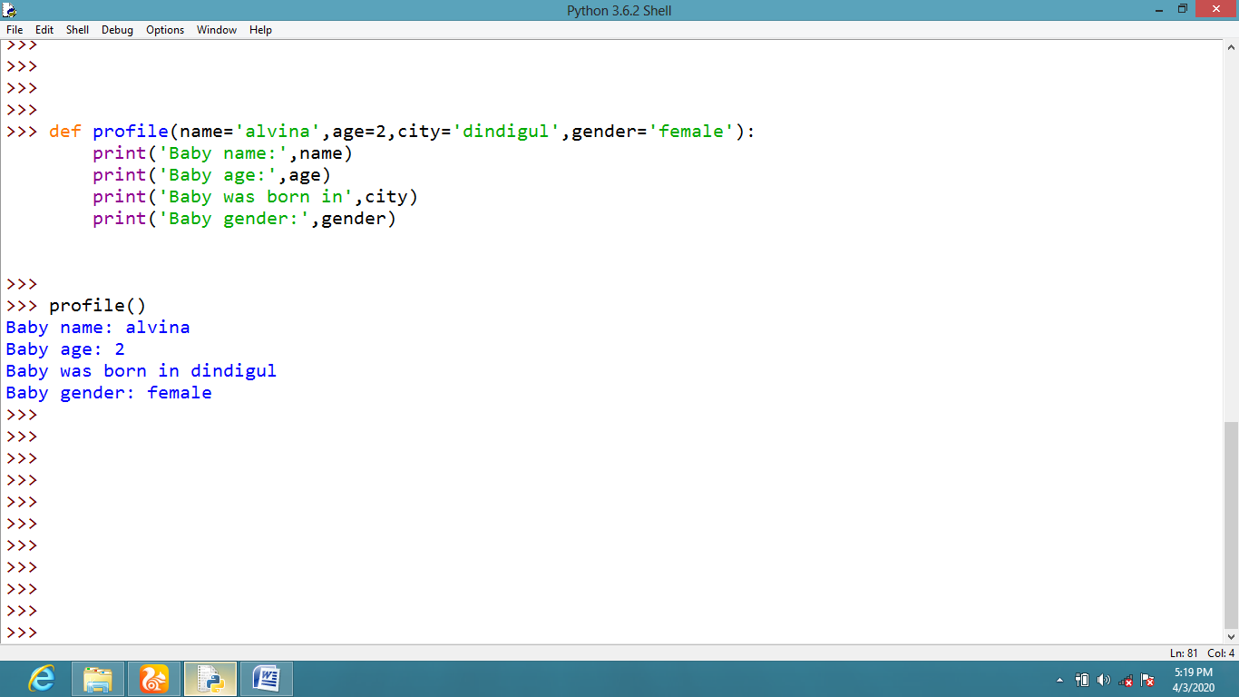
User defined functions with keyword arguments
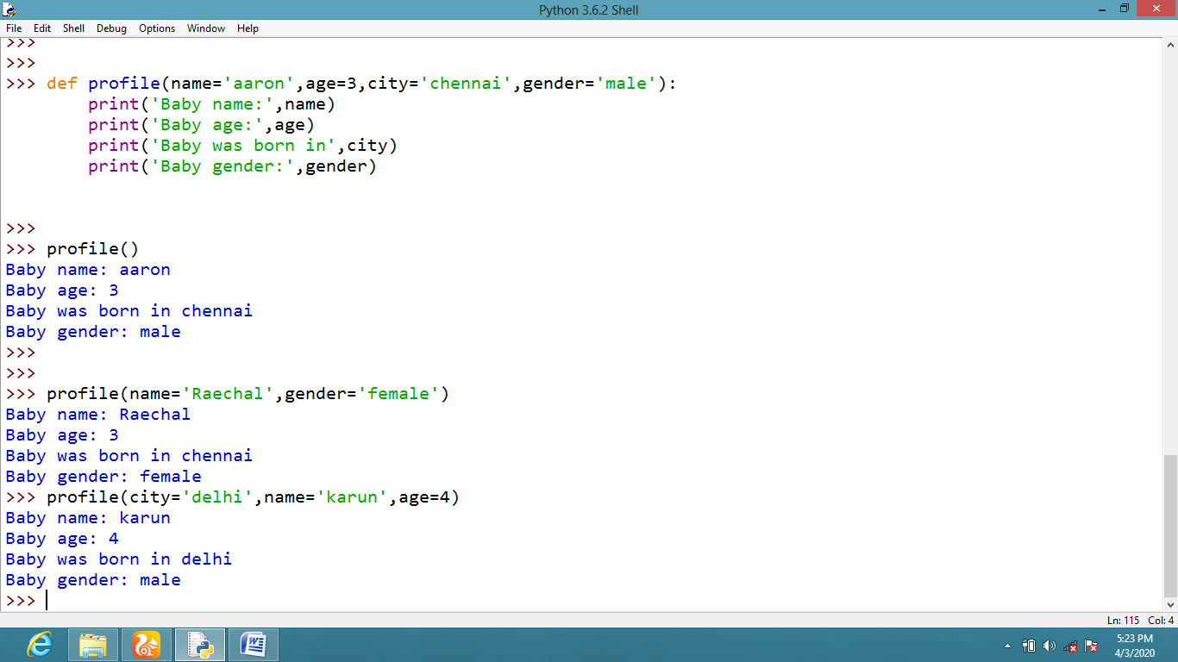
User defined function with positional arguments
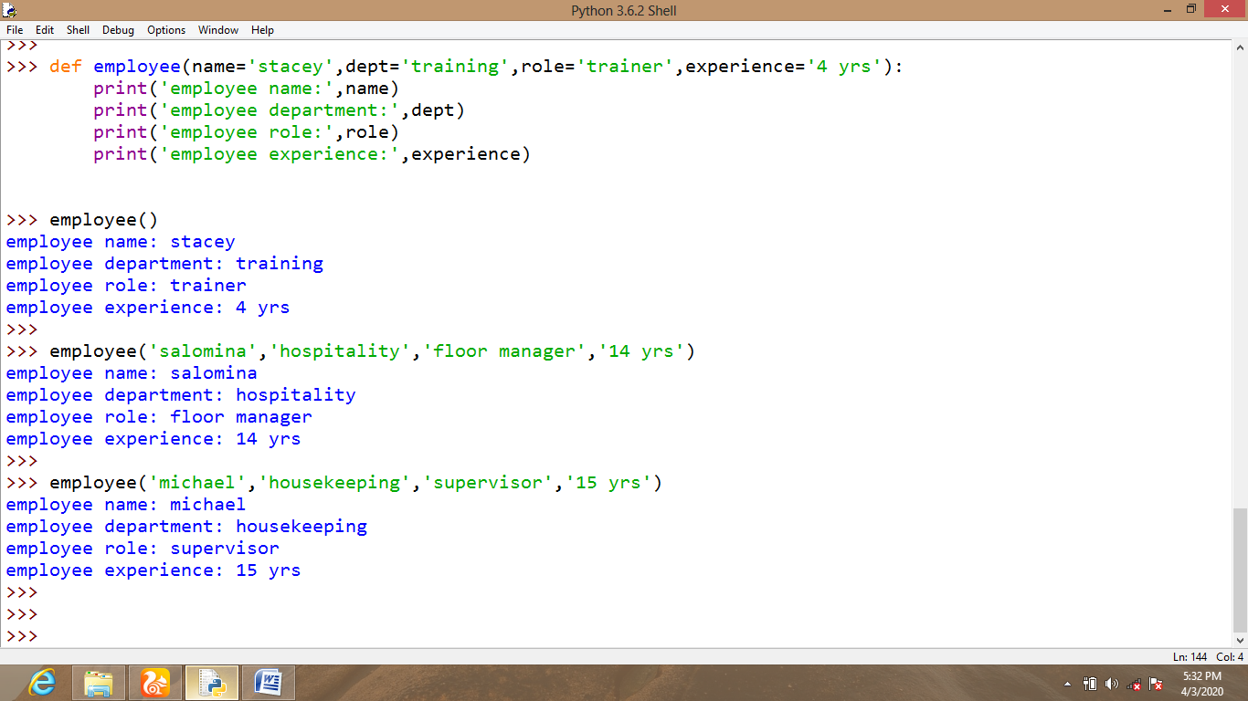
User defined functions with arbitrary arguments
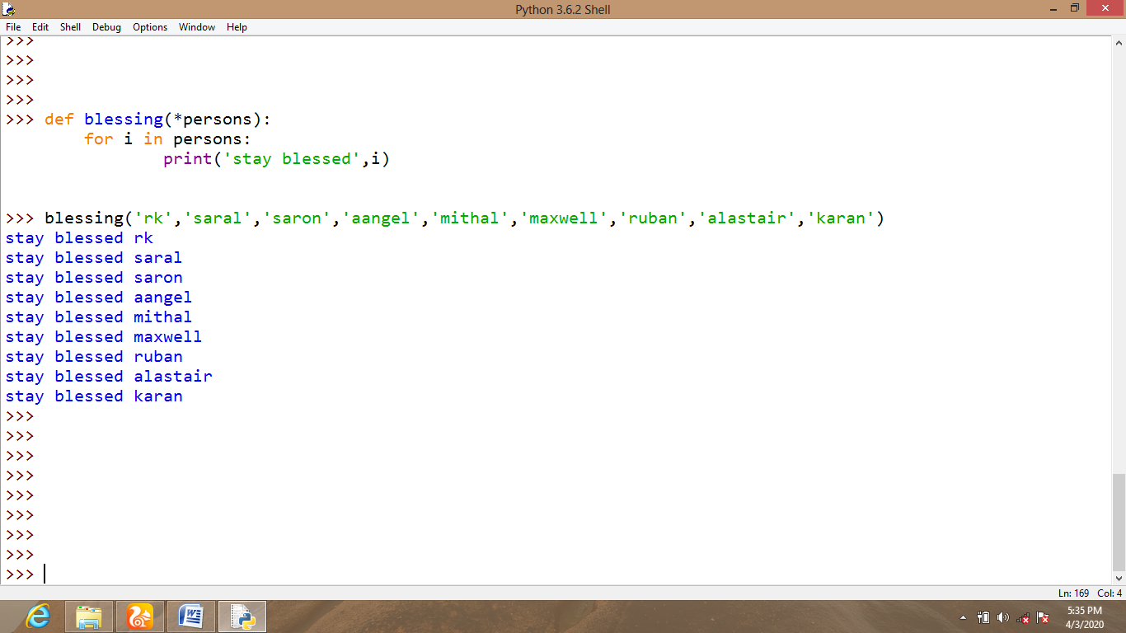
6.4.5 RECURSIVE FUNCTIONS
- In python, recursive functions are mainly used to invoke certain functions to be called itself inside the same function.
- Recursive functions are also called as nested functions in common.

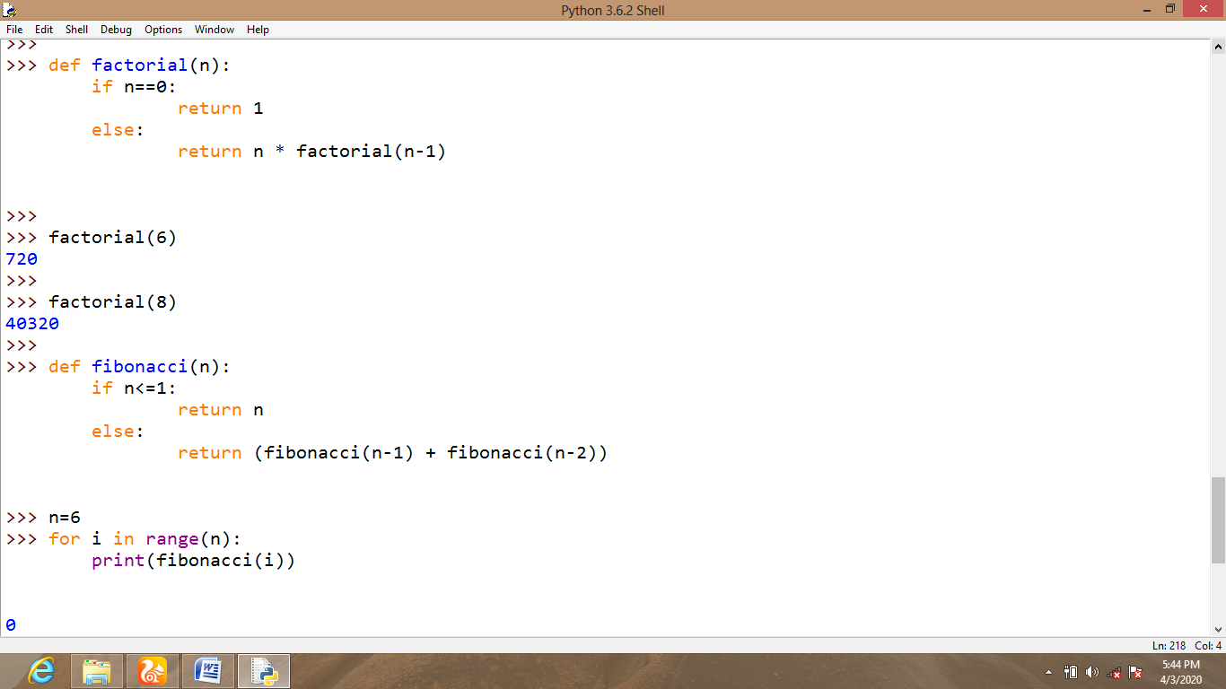
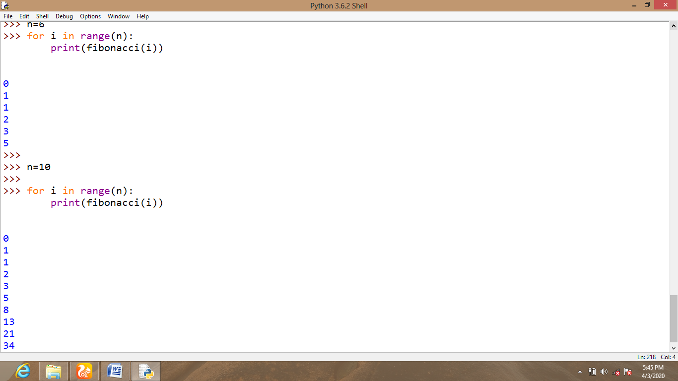
6.4.6. LAMBDA FUNCTIONS
- Lambda function is a nameless function which can be used for a short period of time.
- Lambda function uses lambda keyword instead of def keyword.
- Lambda function is also known as anonymous function.
- Lambda functions are used along with higher order functions.
- Lambda function never uses return keyword.
- Lambda functions frequently used with built in functions like map (), filter () and reduce ().
